**C64 PSU Global Rev. 1**

**Testing v1.0**

# Devices under Test

The tests were conducted with two versions of the C64 PSU Global Rev. 0:

1. Version 115V/230V with TR1 (Hahn BV UI 304 0153) and AC/DC M2 (Mean Well MPM-10-5)
2. Version 230V with TR2 (BREVE TUFVASSONS TEZ10/D230/9V) and AC/DC M1 (RECOM RAC10-05SK/277)

The mains voltage was fix (230VAC) for most measurements. The voltage measurements were conducted with Rev. 0 and Rev. 1 of the PCB.

# Tests

## Testing Under Real Life Conditions

The setup for the function test was both versions, connected to a C64 with different ASSY No., an Ultimate II+ and a joystick switch was attached to the respective mainboard (Figure 1).

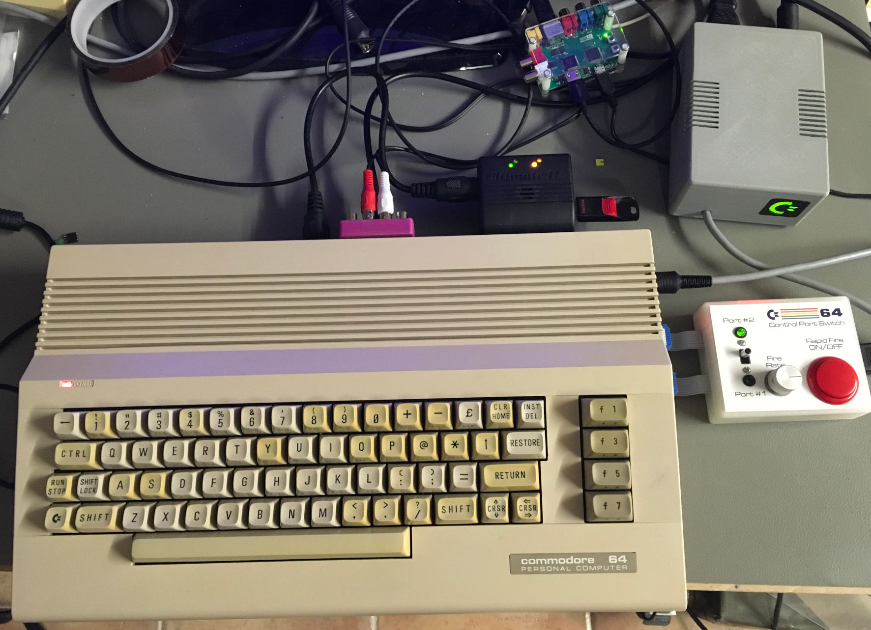

Figure 1: Testing the PSUs under real life conditions

|  |  |  |
| --- | --- | --- |
| **C64 ASSY No.** | **Version A** | **Version B** |
| **250407** | C64 started, software loaded and worked properly | C64 started, software loaded and worked properly |
| **250425** | C64 started, software loaded and worked properly | C64 started, software loaded and worked properly |
| **250466** | C64 started, software loaded and worked properly | C64 started, software loaded and worked properly |
| **250469** | C64 started, software loaded and worked properly | C64 started, software loaded and worked properly |

## Output Voltages with and without Load (Rev. 0)

The load is a 4.7Ω resistor for the 5VDC and a 10Ω resistor for the 9VAC.

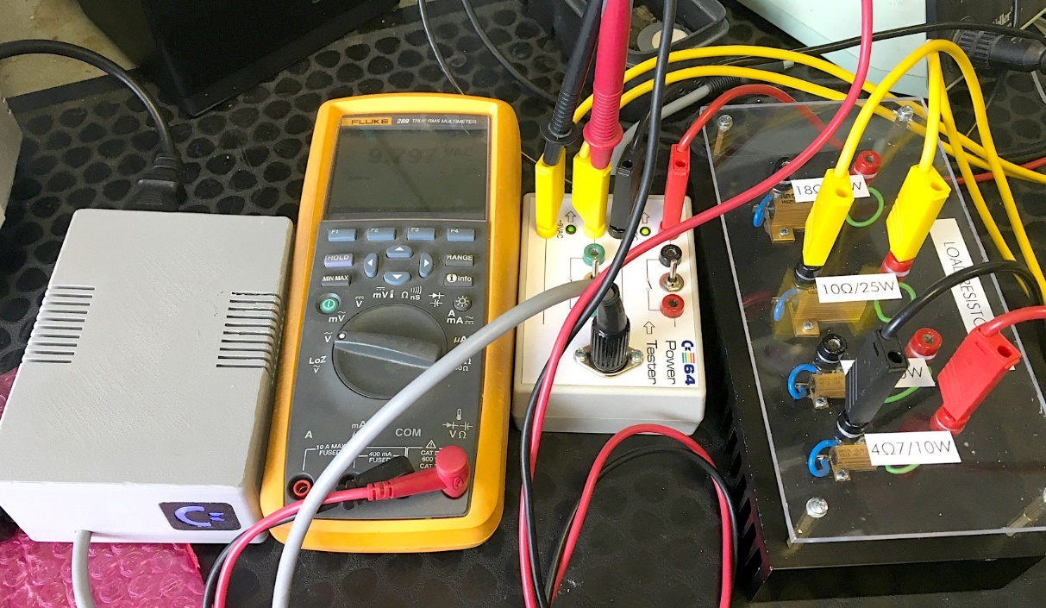

Figure 2: Test Setup

|  |  |  |  |  |
| --- | --- | --- | --- | --- |
| **Device under Test (Rev. 0)** | **No Load** | | **Load** | |
| 5VDC | 9VAC | 5VDC | 9VAC |
| **Version A** | 4.99V | 12.15V | 4.76V | 10.04V |
| **Version B** | 5.00V | 11.61V | 4.73V | 9.73V |

The 9VAC output voltage is not critical, all voltages that are generated from it in the C64 are regulated. An output voltage of about 12V at no load is a normal value, which can be observed with transformers, which will output the nominal voltage at nominal load.

The value of the 5VDC is more critical here. The voltage drop of 250mV @ 1A is resulting from the voltage drop over the PCB tracks, the fuse, the connectors and the cable. It does not seem to be critical, since all ASSY Numbers, which are tried out, worked flawless over a longer time. Anyways, this voltage drop should be investigated further and minimized.

## Output Voltages with and without Load (Rev. 1)

In Rev. 1, the connection for a current panel meter was dropped, since the accuracy of those panel meters was considered to be not sufficient. This should have an effect on the voltage drop on the PCB. Thus, the measurements conducted with Rev. 0 were repeated with Rev. 1 to observe the effects of the modification.

|  |  |  |  |
| --- | --- | --- | --- |
| **Voltage** | **No load** | **Load** | **Current** |
| +5VDC | 4.995V | 4.803V | 0.989A |
| 9VAC | 12.500VAC | 10.234VAC | 1.008A |

The voltage-drop (192mV) is now tracked within the system.

The voltage-drop measured directly across the 5V fuse F2 was 68.5mV (of which 10mV are caused by the fuse holder). The complete voltage-drop measured over pin 1 and pin 2 of the output jack J3 was 100mV. The output cable (88cm) contributed another 92mV. So, the cable contributes about half of the voltage drop. An AWG21/0.5mm² cable provides a resistance of 43.4Ω per meter. Since both, the +5V and the GND wire have to be taken into account, an 88cm cable has a resistance 76.4Ω. The calculated voltage drop is about 76mV. The connector of the test box might be responsible for the difference.

Conclusion: The output cable should be as short as possible. A different fuse type might have a less voltage-drop (a not approved 10A fuse produces only 5mV of drop).

The board design is good. 2oz of copper instead of 1oz are not worth the extra price, since the copper traces provide the least part of the voltage drop.

The measurements were carried out with an eevBlog 121GW multimeter.

## Ripple measurement

The +5V output voltage was inspected with a scope (Rigol MSO4024). A load of 4.7Ω was applied to this output.

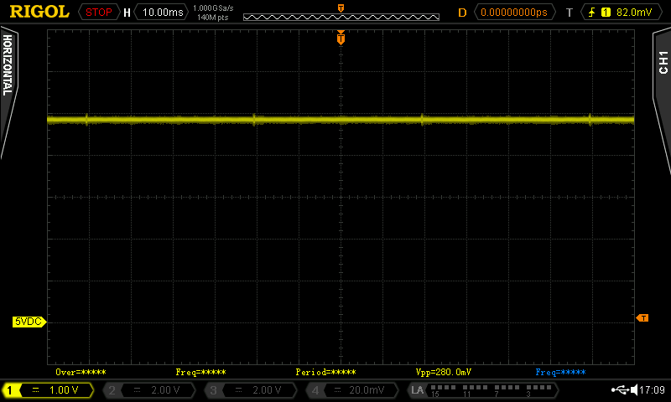

Figure 3: 5VDC (DC coupling, 1V/div and 10ms/div)

A voltage spike was found every 40ms. This should now be investigated further. #

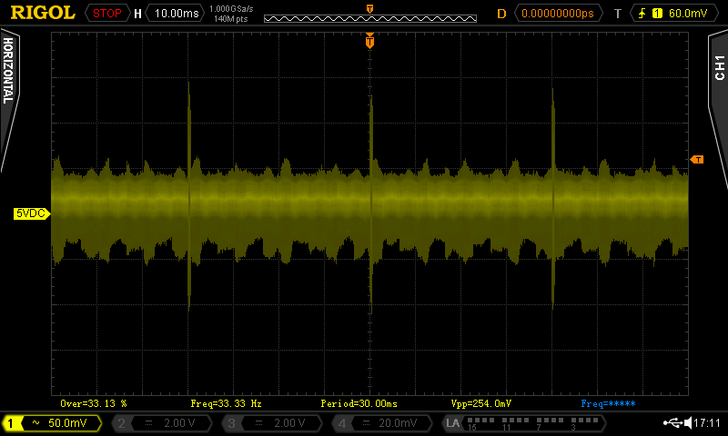

Figure 4: AC coupling, 50mV/div and 10ms/div

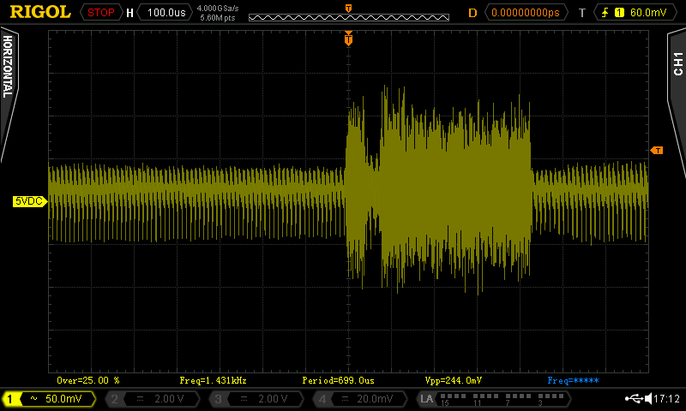

Figure 5: AC coupling, 50mV/div, 100µs/div

The spike or burst that occurs every 40ms has 244mVPP (peak to peak voltage) for about 430µs, while the remaining time, the ripple says within 100mVPP. This is not unusual. The input filter of the C64 might flatten this further. A measurement was not conducted.

## 115V mains voltage test (Rev. 0)

The test was conducted with the switchable version of the power supply (Version A), which was connected to an adjustable isolating transformer (Figure 6).

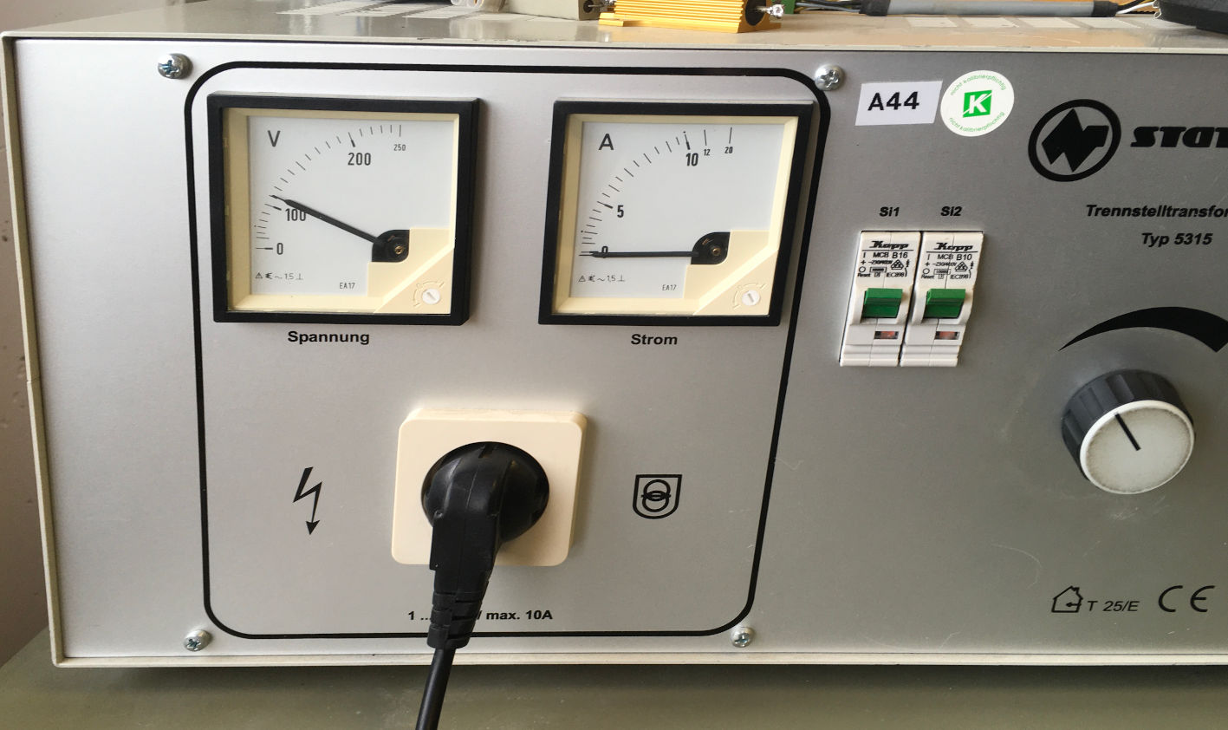

Figure 6: Adjustable isolating transformer

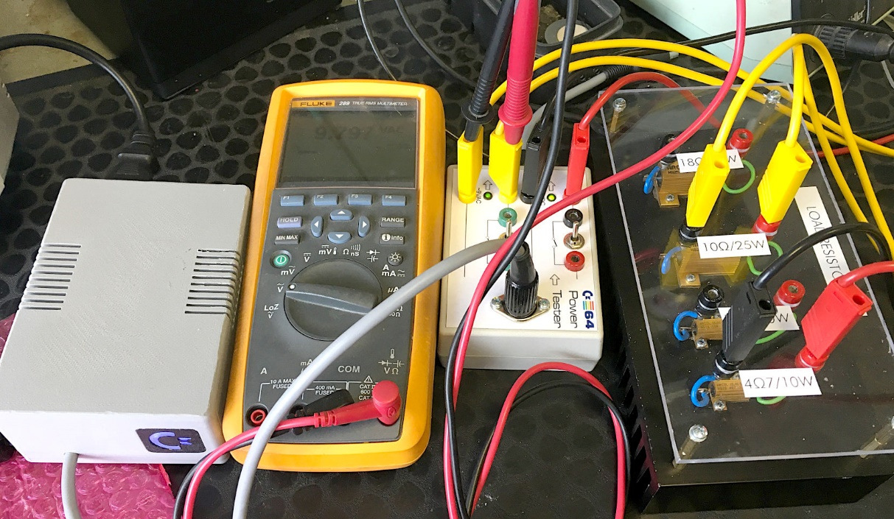

Figure 7: Test Setup for the 115VAC mains test

The isolating transformer was adjusted to approximately 110V. As expected, the +5VDC reading did not differ from the reading at 230V mains voltage. The 9VAC showed 9.8VAC with a 10Ω load. This test was also a proof of concept for the mains voltage selector switch.

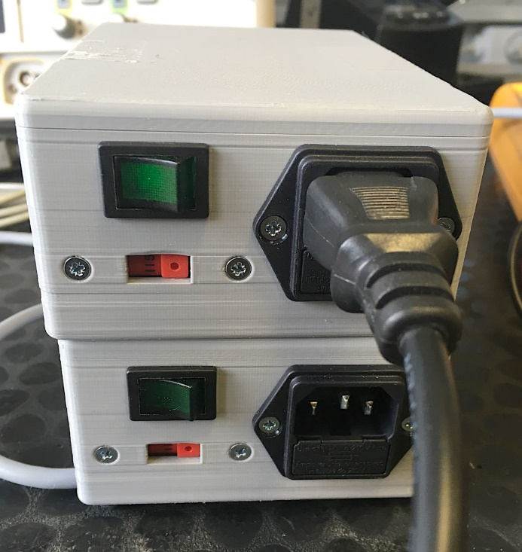

Figure 8: Dim power switch

At 110VAC, the illuminated power switch was not bright at all (Figure 8). This was expected, since the switch was designed for 230V. This is not harmful, but as a conclusion, for 115V, an illuminated switch is not required.

## Thermal Tests (Rev. 0)

The thermal behavior of the PSU Global might be critical, so this was investigated in depth. The critical temperature of PLA is 55°C to 60°C (when it softens) depending on the type. Since it was a goal to stay away from the critical temperature, it was repeated several times with modified cases. First, more ventilation slots were added in a second step the case has been made higher to get farther away from the transformer, which turned out to radiate most of the heat. A significant difference could not be achieved with the modifications of the case, though.

The temperatures were measured with a thermo couple positioned in the middle of the top shell right above the transformer and the (5V) AC/DC converter (Figure 9).

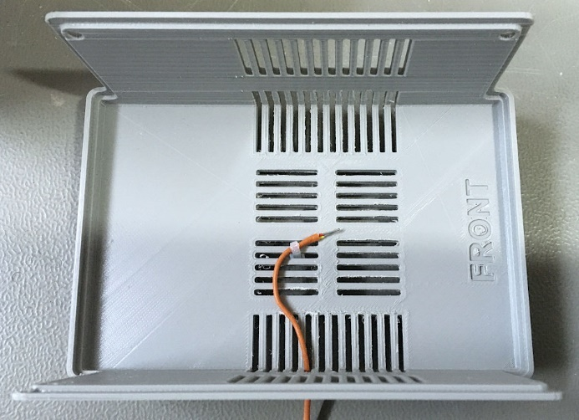

Figure 9: Position of the thermo-couple

The voltages were loaded with 4.7Ω on +5V and 10Ω on 9VAC and the temperatures were documented over the course of the test.

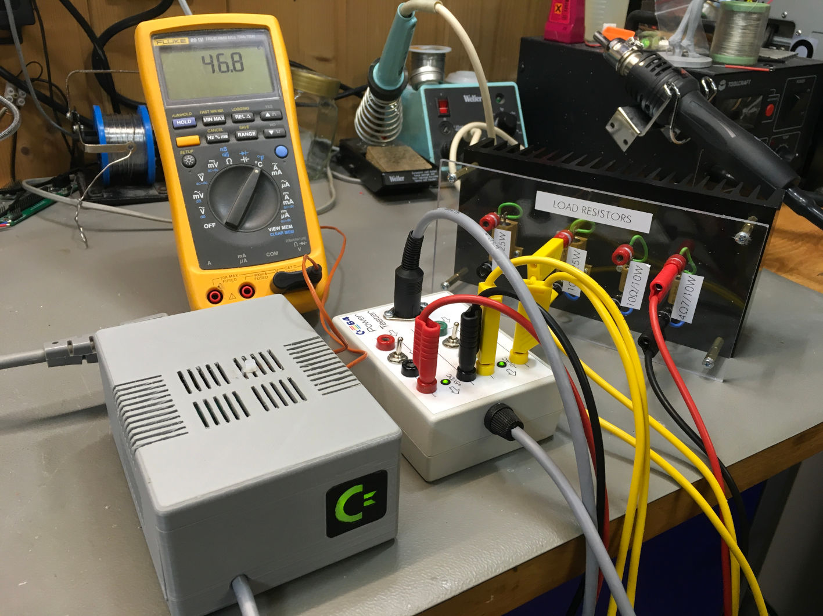

Figure 10: Test Setup (resistor load)

|  |  |  |  |
| --- | --- | --- | --- |
| Measurement | #1 | #2 | #3 |
| Time | 0:00h | 0:28h | 2:16h |
| Temperature | 22.2°C | 34.1°C | 46.7°C |

In a second test, a real-life setup was tested. The highest current consumption is attained with an ASSY250407 C64. Further, an Ultimate II+ and a control port switch were connected to this computer. The temperatures were measures with the same setup like before.

|  |  |  |  |  |
| --- | --- | --- | --- | --- |
| Measurement | #1 | #2 | #3 | #4 |
| Time | 0:00h | 0:54h | 1:49h | 2:29h |
| Temperature | 22.7°C | 39.3°C | 42.5°C | 43.5°C |

**Conclusion of the temperature measurements:** With the resistor load, the temperature rises to about 8°C below the lowest critical temperature (55°C) defined before. The ambient temperature was about 22°C. Thus, at an ambient temperature of 30°C, the critical temperature is reached.

With a real-life load, the temperature stays 11°C below the 55°C (ambient temperature 23°C). Thus, the critical temperature is reached at an ambient temperature of 34°C.

The critical temperature for the electronic components inside is 70°C, which is by far not reached.

**Recommendation:** do not use the power supply at an ambient temperature of >30°C if the case is made from PLA or use ABS for printing, which has a much higher critical temperature.

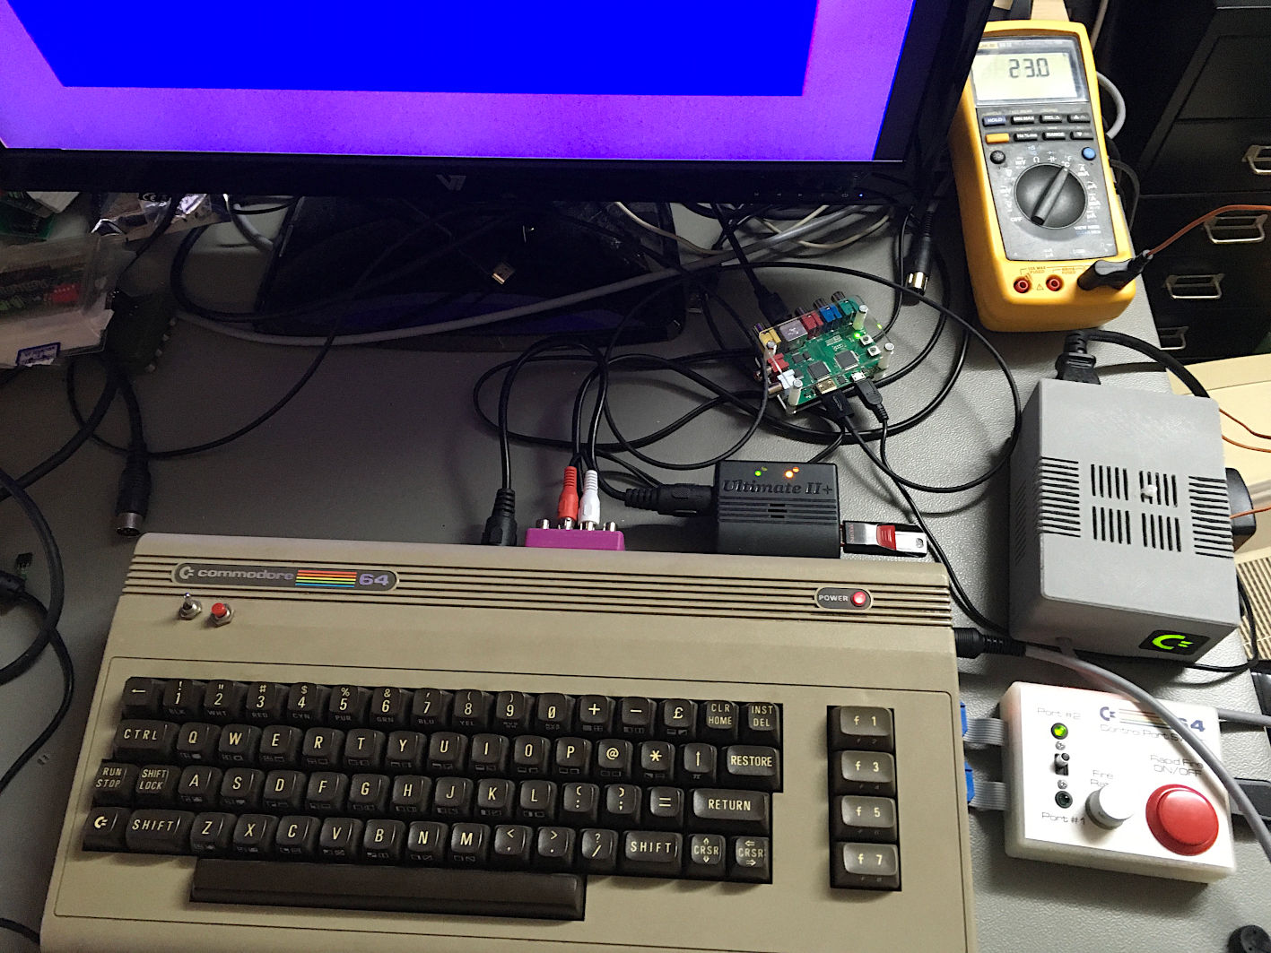

Figure 11: Real-life thermal test setup

# Conclusion

**Both, Rev. 0 and Rev. 1 are functional.** The smaller voltage-drop of Rev. 1 is a small improvement. The case should be printed with ABS for an improved temperature range.

The all tested C64 were working without any problems while powered. Note: the original C64 PSU was set to about 5.2V or 5.3V. It is not sure, if this was really required or just a precaution. The AC/DC module used for this project is used for other C64 PSUs, too. It cannot be adjusted to a higher output. Its output is 5.00V. It might be possible, that a few C64s, which work perfectly with the original power supply do not work with this PSU (or any other, that uses AC/DC modules). In this case, it might be interesting to replace the fuse with a higher rated fuse (the AC/DC modules have an overload protection) and keep the output cable as short as possible.